**Project: Operationalizing a Co-working Space Service**

1. **Build and Deploy Containers to ECR**
   1. **Store Docker images in ECR (A screenshot shows Docker image pushed to ECR)**

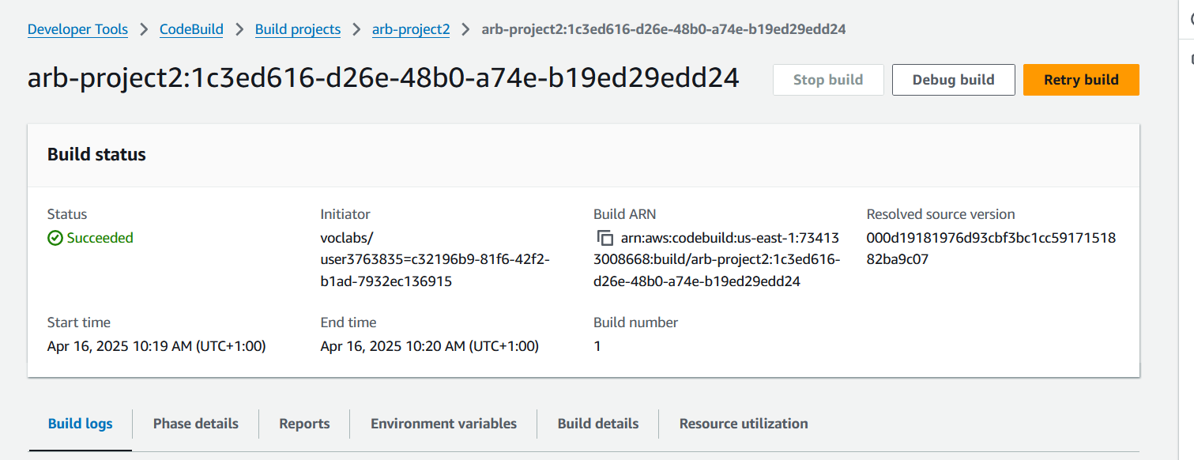

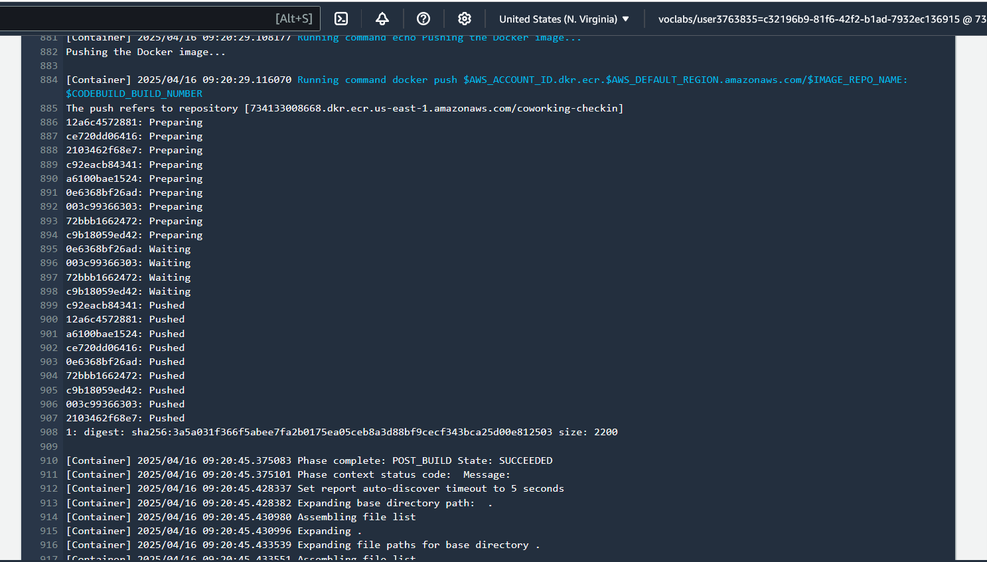

* 1. **Run CodeBuild pipeline to deploy Docker image to AWS ECR (A screenshot of the AWS CodeBuild pipeline shows that the build process was triggered automatically and pushed a built Docker image into ECR)**

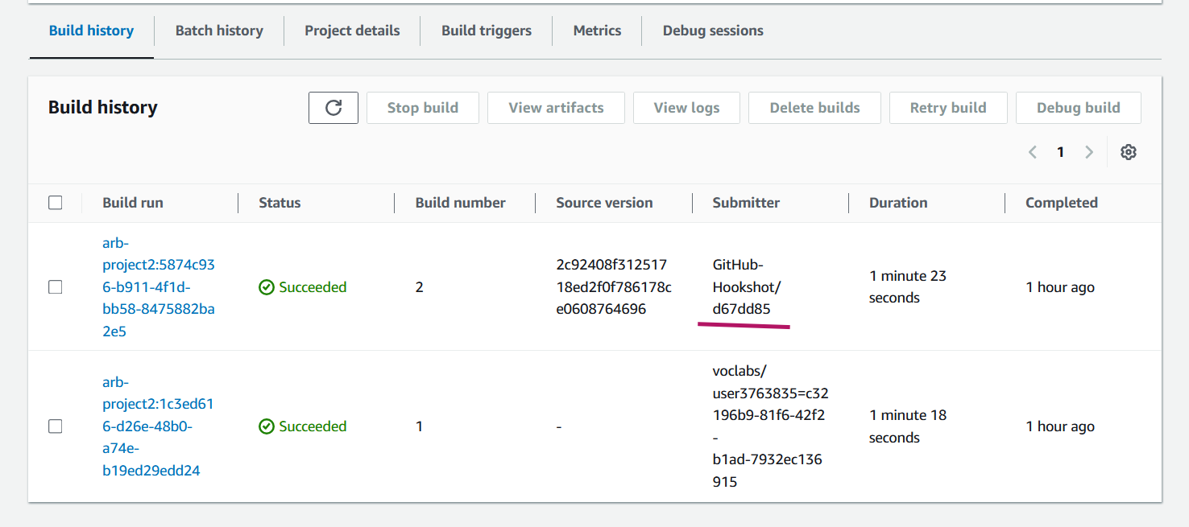

**ECR Repo – images**

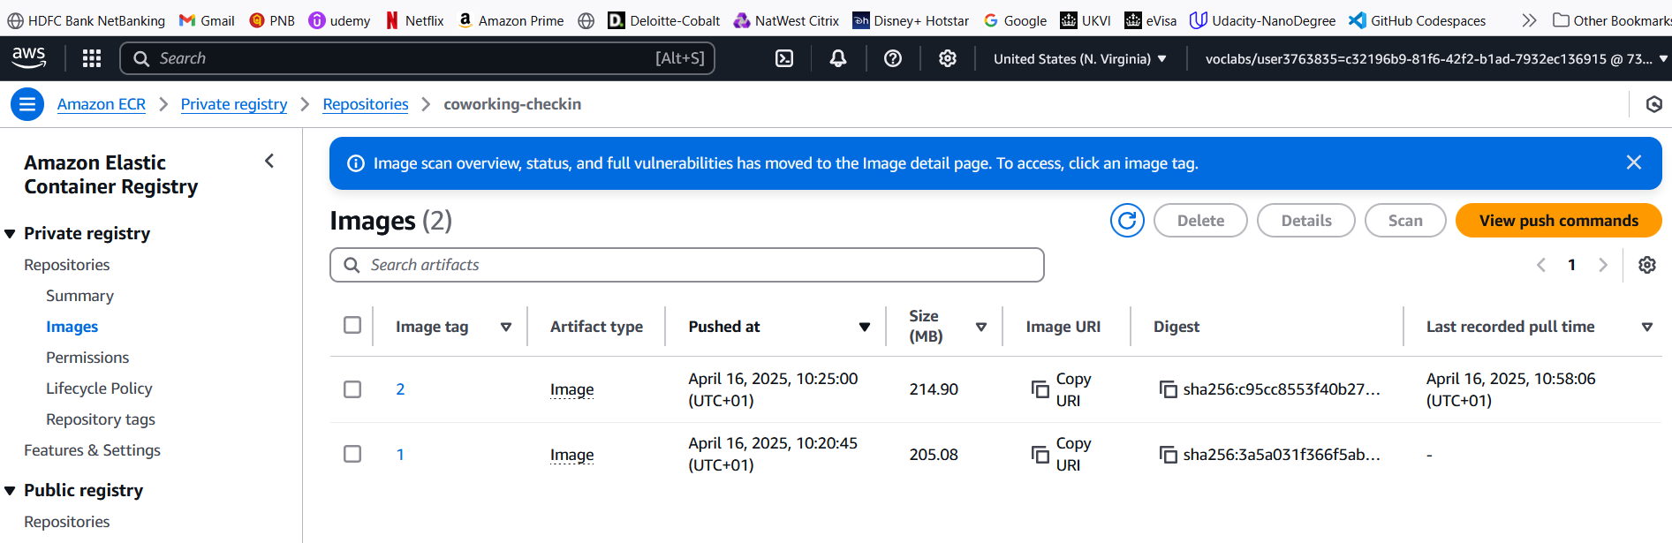

1. **Kubernetes Configuration**
   1. **Create functional Kubernetes YAML configuration files**

Provided in the zip file / githhub repo : <https://github.com/arbaravind/udacity-project3>

* 1. Successfully deploy Kubernetes service

kubectl get svc

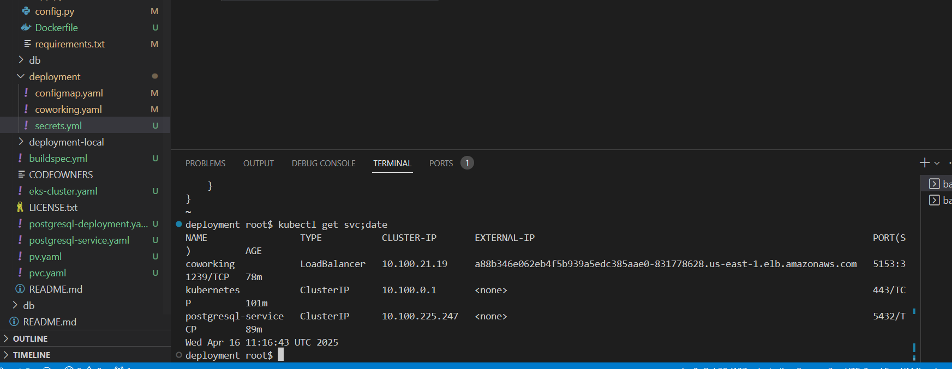

kubectl describe deployment coworking

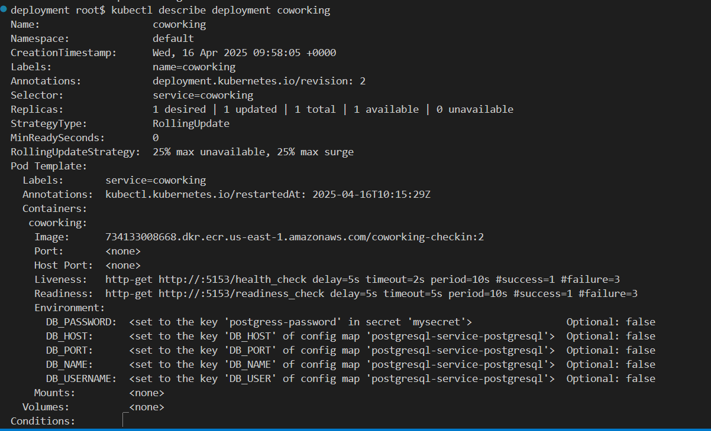

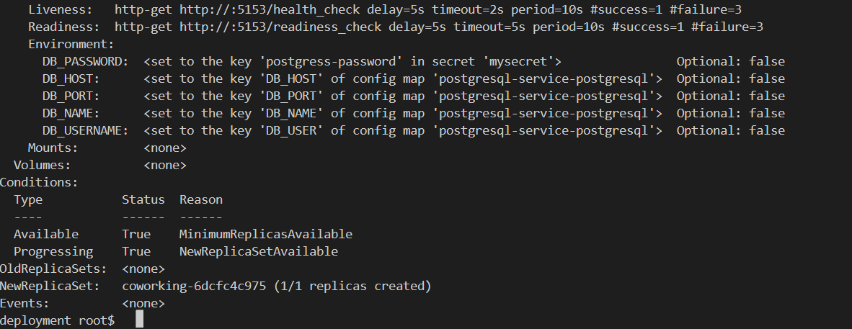

kubectl get pods

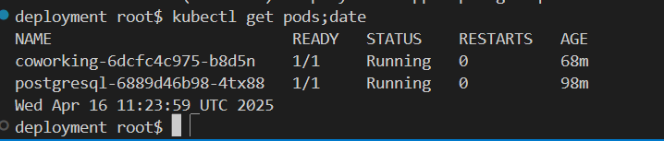

kubectl describe svc postgresql-service

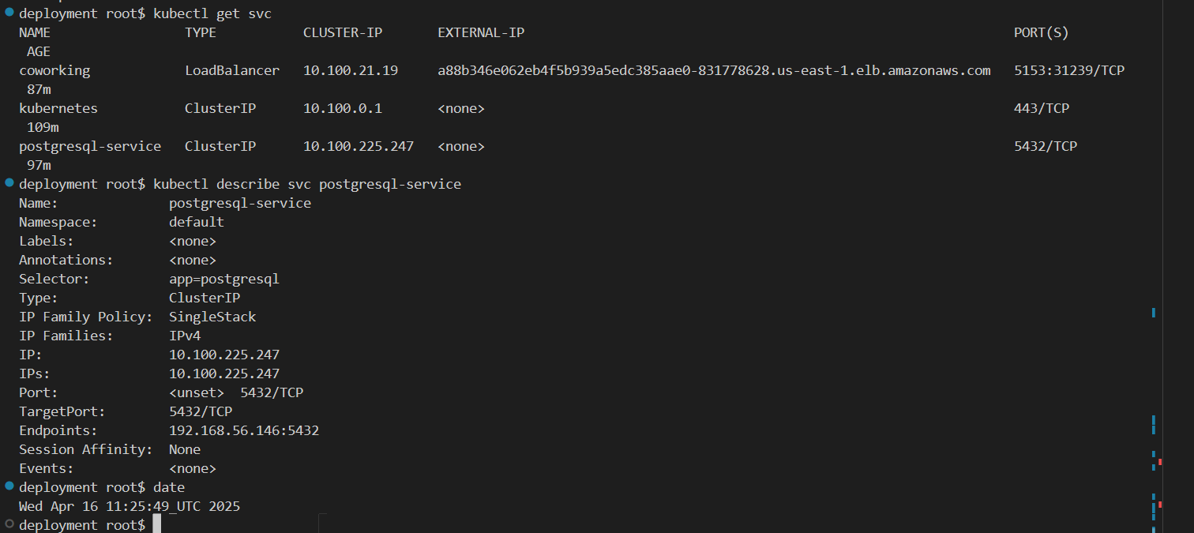

1. **Logging and Documentation**
   1. Write a concise and well-structured README. (included in github)
   2. Review CloudWatch Container Insights logs to confirm that the application is operating normally

Cloudwatch configuration

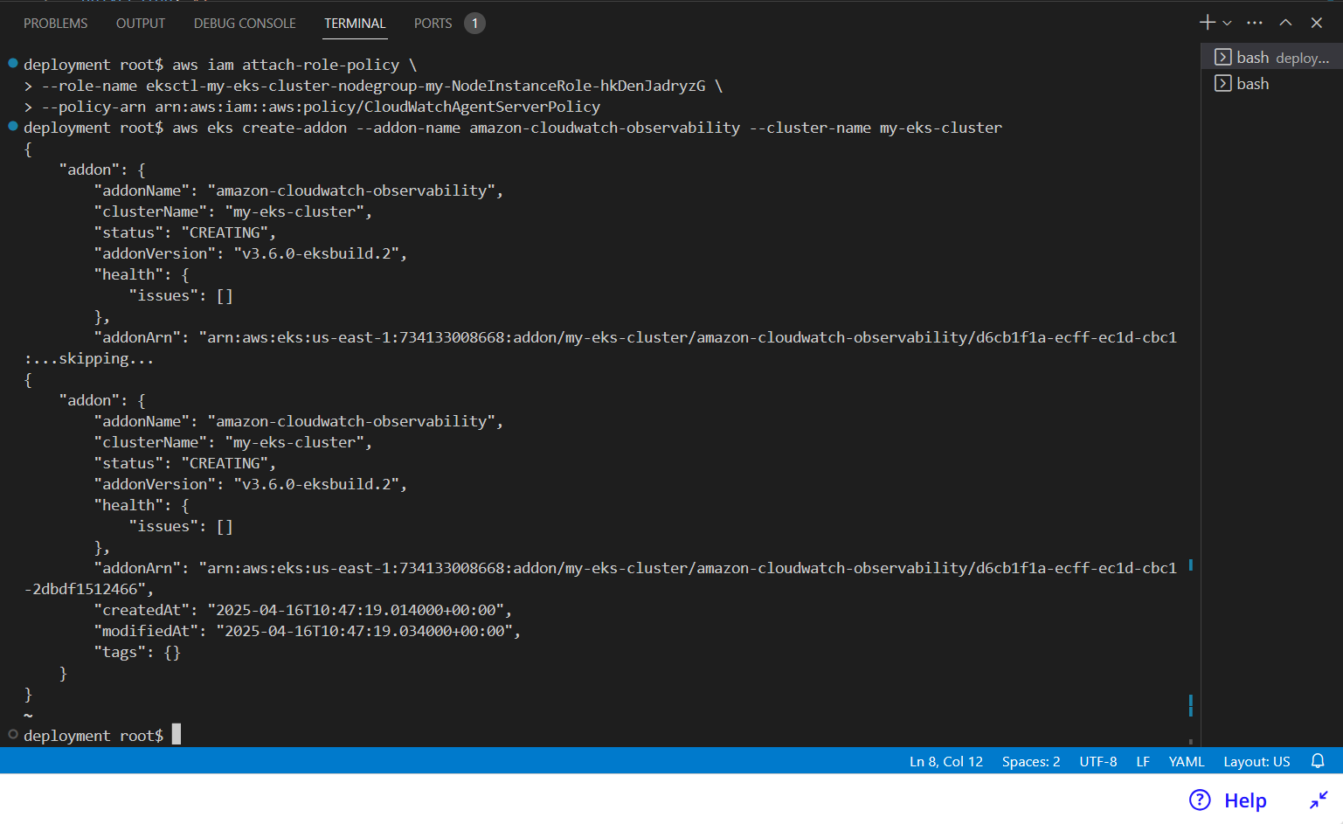

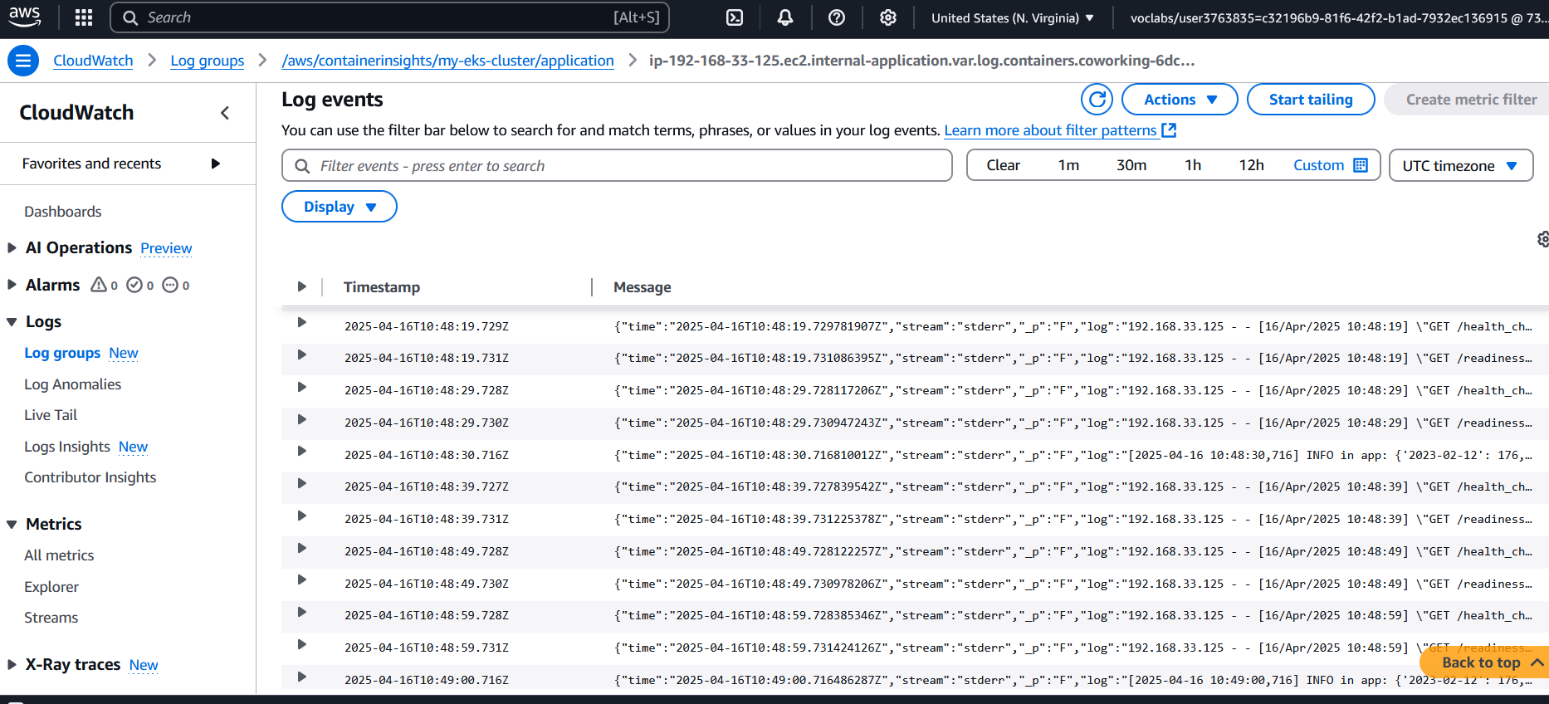

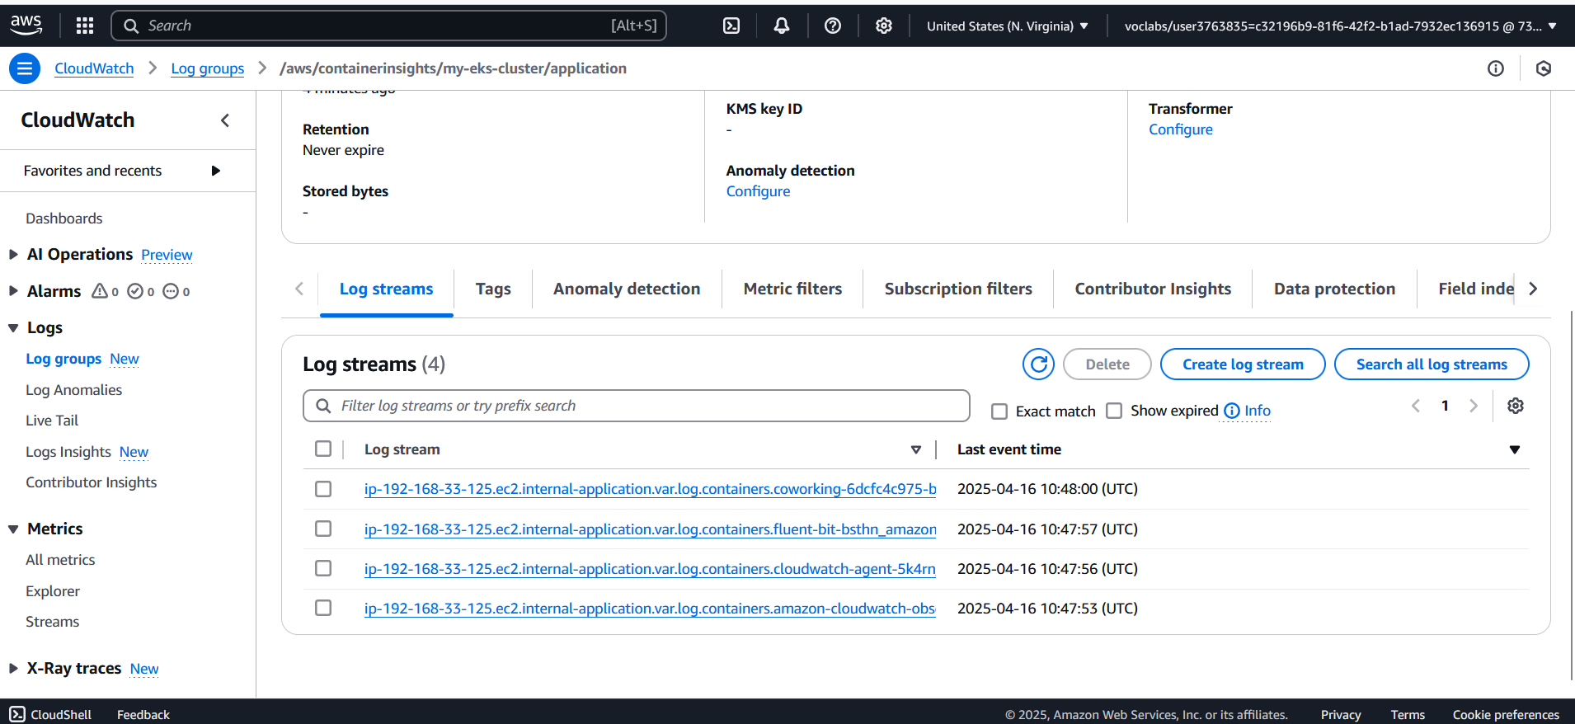

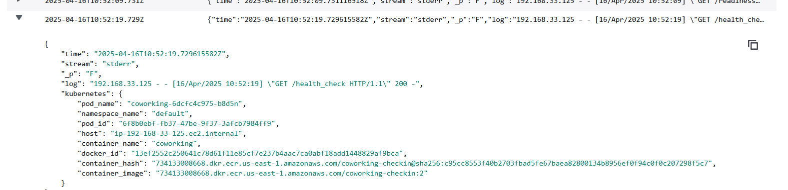

Curl command output with external IP address

